Saxons Orienteering Club  invite you to a WEST KENT SERIES Orienteering Event at  Somerhill School  Sunday 7th June, 2009 | 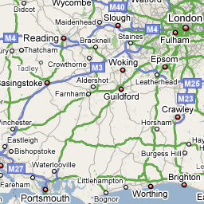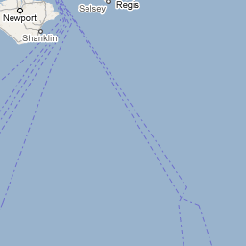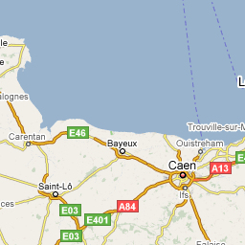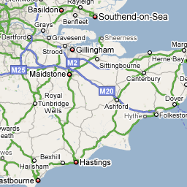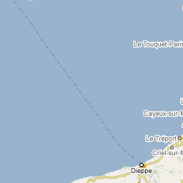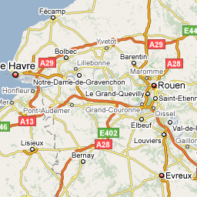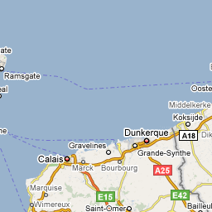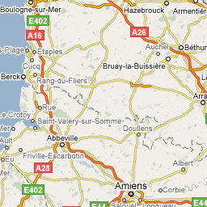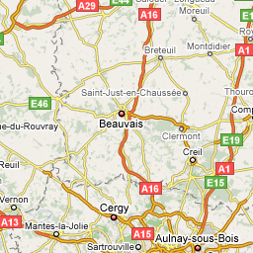  Map data ©2009 Tele Atlas - Terms of Use

 | print version with map
Directions: | One mile east of Tonbridge on the B2017 Five Oak Green Road. TN11 0NJ
Grid Ref: | TN11 0NJ (Google Map) (Streetmap) (Multimap)
Courses: | Course A will be a 60 minute score course through the parklands, woods and ornate gardens of Somerhill. Suitable for all abilities.  Course B will be about 2 km long and ideal for beginners, juniors and family groups.  Plus a string course especially for the younger juniors.  These courses are ideal for COME and TRY IT for beginners, or for the experienced orienteers wanting a training run.  Coaches will be available to train beginners, and there will also be a training exercise for the intermediate orienteer.
Map and Terrain: | 1:10000 last surveyed 2000, with recent updates. Undulating parkland with surrounding woods within the Somerhill School grounds.
Registration: | 10.00 to 12.30 hrs
Starts: | 10.00 to 12.30 hrs
Fees: | £4 Senior £1 Junior (Saxons juniors free), dibber hire £1
Further Info: | Courses close at 2.00pm.
Organiser: | Jerry Purkis development@saxons-oc.org
Planner: | Jerry Purkis

More information can be found on the Clubs website at http://www.saxons-oc.org
If you know in advance that you are intending to compete in this event it would be appreciated if you could e-mail the organiser, saying which course you’d like a map for. This will allow us to make a reasonable estimate of the minimum number of maps to be printed. Extra maps will be printed for those who prefer to just turn up on the day but we do like to ensure that there is a map for everybody without excessive wastage.
COMPETITORS TAKE PART IN THIS EVENT AT THEIR OWN RISK

