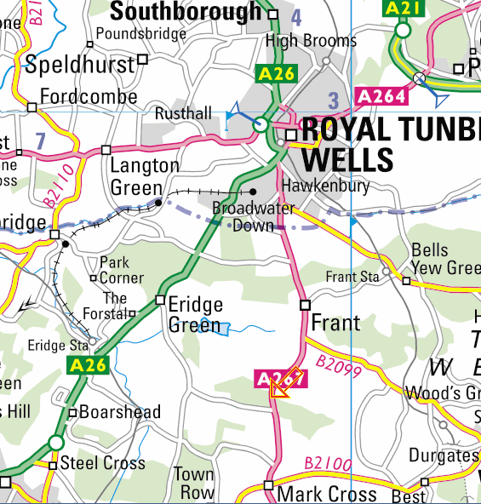
Hospital A&E
No right turn going south, continue and find a safe place to turn
Showers next to Masonicne
Main Harvester Event
Hargate Forest Chasing Sprint
Frant Railway Station
restaurantss
Tunbridge Wells RailwayStation
Sainsburys Toilets

Travel and Weekend Information:
TRAVEL TO ERIDGE PARK TQ 583 335 PostCode TN3 9HT
6km south of Tunbridge Wells, 2km south of Frant on A267.
Police have advised that there is no right turn into Eridge Park from the A267. You need to find a safe place to turn which could be as far as Mark Cross.

TRAVEL TO HARGATE FOREST TQ 575 375 Post Code TN2 5NY
2km S of Tunbridge Wells on west end of Broadwater Down which links A26 and A267.
Park in on side of road west of the church.
The nearest public toilets will be at Sainsburys in Tunbridge Wells, or the Mainline station.

Nearest Train Stations to Hargate Forest : Tunbridge Wells Station 2km
Nearest Train Stations to Eridge Park : Tunbridge Wells Station 6km, Frant Station 5km.
For details on train services: www.thetrainline.com (for travel from London or Gatwick)
For details of bus services along the A267 www.travelinesoutheast.org.uk 252 bus every hour
Minibus service: www.gmstravel.com (8 person minibus)
SHOWERS: Basic shower facilities will be available (for free) 6-8.30pm Saturday, at Cardogan recreation ground. Turn right from A26 between speed camera and St Johns Leisure Centre into Masonic Hall and then take the left drive to the changing room showers.
St Johns Leisure Centre, opposite, for a swim, will be open on Sunday. Not available on Saturday evening.
CAMPING: In Eridge Park. From 12 noon Saturday .Please park and camp as directed by the marshalls.
No open fires or BBQs. No dogs allowed.
There is a limited supply of fresh water. Please bring your own.
Facilities:
Ultrasport (for that extra night torch)
Continental Catering (for burgers, sausages and bacon sandwiches and tea and cake).
First Aid
Nearest A&E at Tunbridge Wells (see map)

