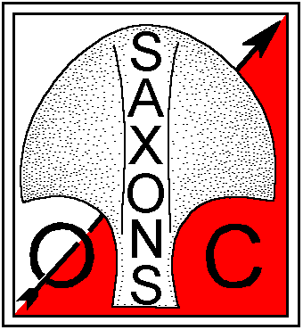 | Saxons Orienteering Club  Ightham Sun 16 Dec 2012  Level C Ranking Sunday Series
Brown, Blue, Green, L Green, Orange Yellow

Location: TB15 0HB, Grid ref TQ 577557, park on side road south of A25 leading to Crown Point Inn, 4km east of Sevenoaks. Nearest Station: Sevenoaks, 5km.

When: Sunday 16 Dec, registration from 10 am-11.30, starts from 10.30-12.00, courses close 2pm.

Start and Finish: The start will be a 1.2km easy walk along a public bridleway.
Courses Yellow, Orange, L Green will finish close to the start.
Courses Green, Blue, Brown will finish 400m from registration (not on route to start).

Road Crossings:
Courses Orange, Light Green, Green, Blue and Brown cross a minor road.
Courses Blue and Brown will have a timed road crossing of the A25.

Terrain: Good runnable woodland with a network of paths and plenty of contour and point features. Map 1:10,000 5m contours, will have minor updates.

Cost: £7 adults (non British Orienteering +£2), Juniors £3, SI dibber hire £1

Facilities: It is hoped that the Crown Point Inn will open their toilet facilities early. Please buy a drink or food later.

Planner: Mark Glaisher
Controller: Andrew Evans DFOK
Organiser: Jerry Purkis development@saxons-oc.org 07582 430008 M, 01892 536332 H

MORE INFORMATION on the Events section of www.saxons-oc.org .
Nearest small hosp, Sevenoaks, large A&E Pembury or Maidstone.

